

**DBMS**

**(**CS304**)**

**TOPIC : CAR INSURANCE DATABASE**

**Under The Guidance of : UMA S**

**Done By : Group 6**

**Group Members :**

AQTAR PARVEEZ - 18BCS010

ARUN AVK - 18BCS012

NISHEER V - 18BCS061

PALSHINI B - 18BCS062

PAVAN KUMAR N - 18BCS064

R DHANUSH KUMAR - 18BCS071

R NAVEEN DEVANG - 18BCS072

RAGHU PRASAD JN- 18BCS073

VIVEK SURESH - I8BCS111

**INTRODUCTION**

A database management system (DBMS) refers to the technology for creating and managing databases. Basically DBMS is a software tool to organize (create, retrieve, update and manage) data in a database.

The main aim of a DBMS is to supply a way to store up and retrieve database information that is both convenient and efficient. By data, we mean known facts that can be recorded and that have embedded meaning. Normally people use software such as Microsoft ACCESS, or EXCEL to store data in the form of database.

**AIM**

This project is aim at computerizing the manual process of vehicle insurance system. It is implemented using MySQL respectively. The project consists of thirteen forms(entity) mainly. Each entity will have its own services.

**The services of a vehicle insurance system can include:**

* Providing people insurance facilities during emergency situations.
* Storing personal information of customers in more secured manner.
* Planning detailed checklist.
* customer list preparation.
* Identification of accident incidents.

**Design**

Design is an iterative process rarely in the real world is a problem specified such that there is a unique optimal solution. Thus the designer works iteratively.

**User Interface**

We are familiar with the syntax of MySQL, hence we have used MySQL syntax and queries for interface between users and server.

**ANALYSIS & REQUIREMENT SPECIFICATION**

**Purpose:**

The purpose of this project is to outline vehicle insurance data and requirements, to recommend data management solutions and to provide information regarding the vehicle insurance. The purpose of this project is to develop a data management system to consolidate, organize, document, store and distribute information related to vehicle insurance management system.

A centralized database created to consolidate data, allowing integrated, long term analyses, and dynamic search ability with user friendly query tools to be performed to support adaptive management. Many data collection, analysis and presentation software programs that are currently being used must be able to interface with any new data management system. Continuity with consistent data collection methodology is enforced by a common database system, allowing for standardized format for forms ad reports between projects.

**Scope:**

The scope of the project is managing a consistency and storage of data by dedicated data administrator. It provides most of the features that a Database Management System should have. It is developed by using MySQL database. It has been implemented in WINDOWS platform.

**FUNCTIONAL REQUIREMENTS:**

**Three Modules are used in this project namely Admin & User:**

* Admin: can insert, analyse the tables.
* User: can register their information.

**Non-Functional Requirements:**

**Hardware Specification:**

Processor : i5 Core Processor

Clock speed : 2.5GHz

Monitor : 1024 * 768 Resolution Colour

Keyboard : QWERTY

RAM : 1 GB

**Software Specification:**

MySQL Libraries

MySQL Workbench 8.0 CE

Operating system : Windows10

**DESIGN OF THE PROJECT**

This project has been developed using MySQL software which is queries oriented. Changes at the queries and the way in which it uses a system state may cause anticipated changes in the behavior of other result.

**ER DIAGRAM**

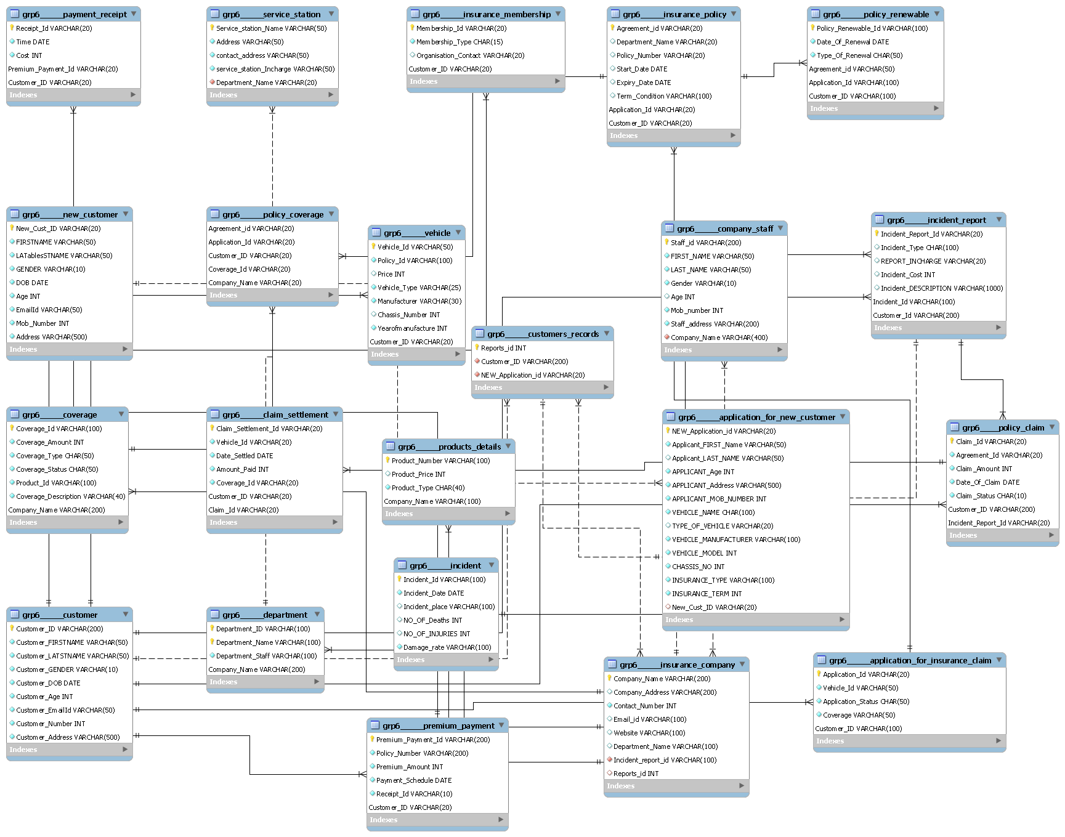

**IMPLEMENTATION**

The project is implemented using MySQL database along with PHP and HTML.

In this project, we use the below mentioned concepts for implementing different type of effects like HTML pages to demonstrate on a web page as a stand-alone or web-based application.

**CONCLUSION**

In this project we have tried to create a database which is easy stores user information, and easy to access and user friendly. The database keeps a backup of the vehicle insurance management data which includes their details and we have tried to implement some of the useful queries on our database.

**FUTURE ENHANCEMENT**

In this, database stores and keeps a backup of the vehicle insurance management data which includes their details. Here we assists with the design, planning and management of a clients vehicle insurance. Further if given chance & time we would like to modify the application by adding external features like Vehicle services, and additional features.

**-------------------------------THANK YOU-------------------------------**